*FIRST* LEGO League Scoring Application

* Designed to be used at small, minimal resource events through to large competitions with tablet input and multiple scorekeepers.
* Simple installation procedure.
* Does not require an Internet connection.
* Supports scoresheet input from computer and tablets.
* Provides the head referee a view of scores that is sortable by team, team number, score and ranking.
* Has a clean and clear audience display screen.

alternatively

The application is installed on a single computer running the Windows operating system. Scoring input, score keeping, time keeping, and audience display can be done from the same computer, or from other computers/tablets (as detailed below), through a browser. These other devices may be of any type that supports a browser, including Mac computers, iPads, Android based tablets or Windows based computers/tablets.

# Preparation

The application is prepared for a competition by configuring the following items:

* Competition name and sponsor logos.
* List of participating teams: Team names can be entered individually or imported from Excel spreadsheet. For each team, team number and descriptive name are required, the system also partially supports city, state, … per team.
* List of referees: Referee names can be entered, and linked to scoresheets at score entry time.
* Table names: Competition tables are individually named (names can be as simple as Table 1, Table 2 or more descriptive). Each scoresheet is associated with a table.
* Competition structure. Two stages are defined by default (practice and qualification). The number of rounds per stage can be configured (default to 1 practice, 3 qualification) and additional stages can be added.

## Scoresheet

* Select team stage and round.
* Score all missions. Each mission has a help button with the mission text.
* Constantly visible cumulative score.
* Verify mission constraints.
* Team signs using mouse or touch input.

## Scorekeeping

* Total match score or individual mission results can be reviewed and edited.
* Scores can be sorted by team, team number, match score, best score or rank
* Negative scores can be configured to display as zero.
* Individual scores can be sent to the audience display automatically or held until published manually (for verification purposes).
* The stage results can be updated on the audience display automatically or manually.

#### Scorekeeper page

## Audience Display

* Display includes rank, team number, team name, best score and individual match scores.
* Includes HYDRODYNAMICS logo, FIRST LEGO League logo, and place for 3 sponsor logos
* Scrolls when there are more teams than can be shown in a single screen.

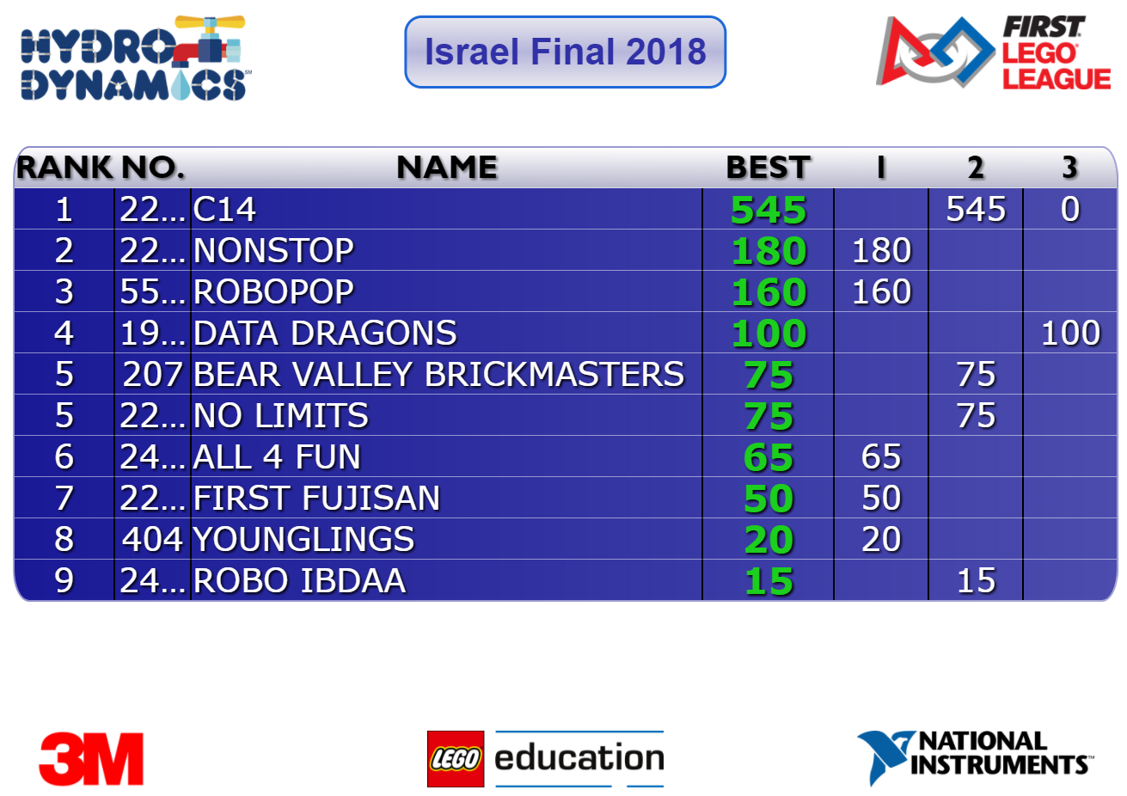

## Timer

* Simple count-down timer.
* Uses traditional FIRST sounds for start and end (can be replaced if desired)

# Support

Multiple channels of support are provided

1. User guide
2. Webinar
3. Submit ticket on fll-tools.com website
4. Slack
5. email